Foodborne Pathogens in Small Ruminants: Antibiotic Use in Livestock
Dr. Dana Pollard, PhD, MS, Assistant Professor
Animal Production Systems
Agricultural Research and Extension Center
Southern University and A&M College
Telephone: (225) 771-3505
Email: dana_pollard@suagcenter.com
“Linking Citizens of Louisiana with Opportunities for Success”

What are antibiotics?

Antibiotics (antimicrobials) are medicines utilized for combating bacterial infections in humans and animals. They can be used for the treatment of ill animals (therapeutic), treatment of a group of animals in close contact with other animals diagnosed with an infectious disease (metaphylaxis), and preventative treatment (prophylaxis). Antibiotics are vital for treating animal and human diseases, ensuring animal health and welfare, and contributing to food safety. Antibiotics have also been used in increasing animal performance.

Antibiotics’ roles in livestock

Treatment, Control, and Prevention:

Animals sometimes become ill from bacterial infections, which can cause pain and suffering. This is a rationale for the veterinary use of antibiotics. Veterinarians have the ethical responsibility that they pledged to treat sickness to stop suffering. Antibiotics are also used to control the spread of disease on a ranch or farm in the face of an outbreak. Since livestock live in small groups and herds, they often share feed and water troughs and come into close contact via licking, resting on each other, and rubbing noses and snouts, which could all result in the escalation of disease transmission. Sometimes, veterinarians suggest antibiotics for disease prevention during periods when livestock are most vulnerable to infection, such as weaning from the mother. This can result in livestock receiving fewer antibiotics than if this preventive dose had not been undertaken. This should be conducted for a restricted duration to cover the period of risk and not be done routinely or systematically. Antibiotics can also prevent the transfer of zoonoses from animals to humans, support food safety, and stop foodborne diseases.

Animal Performance:

Antibiotics are used with livestock for growth promotion. With the use of some antibiotics, certain gut bacteria are destroyed. These antibiotics also increase feed conversion to muscle causing more rapid growth in poultry and livestock.

Withdrawal:

The withdrawal time is the necessary amount of time for the remnants of the drug to deplete to or below the safe concentration as defined by tolerance. After using an antibiotic in an animal or human, it eradicates bacteria and is then broken down by the body into a non-functioning agent. Withdrawal periods of various antibiotics can be 1 or 2 days to weeks.

Antibiotic Resistance

There are twelve classes of antimicrobials, and they may be utilized at different points in the life cycle of farm animals. While there are some antimicrobials used in animals that are not currently used in treating human infections, many of them, such as penicillins, tetracyclines, and sulfonamides, are also used in human medicine. Antibiotic resistance occurs when bacteria are difficult or impossible to treat, and this issue is on the rise globally. Resistance to antibiotics is a result of the overuse, abuse, or substantial use of antibiotics. The inherent risk of any use of antibiotics to select for bacterial resistance contributes to the spread of drug-resistance pathogens in both livestock and humans, posing a relevant risk for public health via different patterns. Although this risk could be a larger issue in comparison to the resistance selection with human medicine, some resistant zoonotic pathogens like Salmonella, Campylobacter, Listeria, or Escherichia coli could be detected in livestock and food of animal origin, or when occasionally found in humans, they could find them to have originated from an animal.

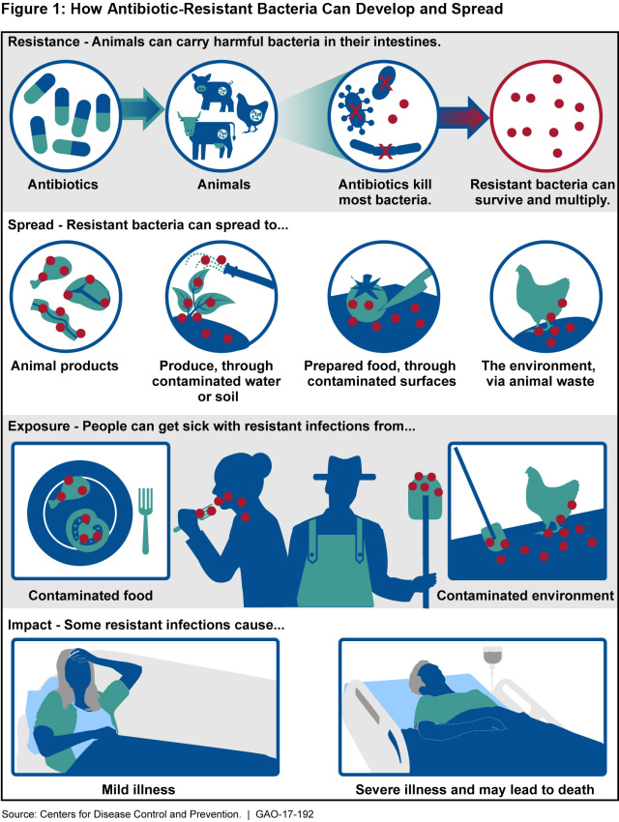

Key Events in Antibiotic Resistance

- 1940 – It was shown that swine and poultry that were fed low levels of broad-spectrum antibiotics grew faster and produced more meat.
- 1951 – Antibiotics were commonly used as growth promoters, in which resistance became evident.
- 2017 – As of January 1, the utilization of antibiotics for growth promotion had been prohibited by the U.S. Food and Drug Administration via Guide for Industry #213. Following this guidance, drug manufacturers no longer sell medically important antibiotics for growth enhancement.
Preventing and Controlling Antibiotic Resistance

- Administer antibiotics under veterinary supervision.
- Refrain from giving antibiotics for preventing diseases in healthy livestock and growth promotion.
- Utilize vaccines to reduce dependence on antibiotics and use other alternatives to antibiotics when available.
- Implement sound practices at all levels of production and processing of food of animal and plant origins.
- Improve farm biosecurity and prevent diseases through better sanitation and hygiene as well as animal welfare.
Funding Source: The USDA 1890 Evans-Allen Program project accession no. 1021121 from the USDA National Institute of Food and Agriculture.

For more information contact:
Dr. Renita W. Marshall, DVM, MS
Telephone: (225) 771-0252
Email: renita_marshall@suagcenter.com
or Dr. Dana Pollard, PhD, MS
Telephone: (225) 771-3505
Email: dana_pollard@suagcenter.com
Southern University Agricultural Research and Extension Center, an entity of the Southern University System, Orlando F. McMeans, Chancellor-Dean; Dennis Shields, System President-Chancellor; Edwin Shorty, Esq., Chair, Board of Supervisors. It is issued in furtherance of the Cooperative Extension Work Act of December 1971, and the Agricultural Research Program, in cooperation with the U.S. Department of Agriculture. All educational programs conducted by the Southern University Agricultural Research and Extension Center are provided to all persons regardless of race, national origin, or disability. © 2022 SU Ag Center.

